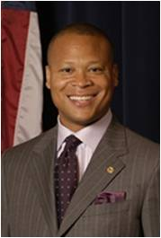
Illinois State Representative
Ken Dunkin, 5th District
Illinois State Senator
Mattie Hunter, 3rd District

The Illinois Hardest Hit Program offers temporary help to homeowners faced with unemployment or underemployment to catch up on their payments and save their home.
Please visit www.illinoishardesthit.org for more details

