3rd District – Illinois
2929 South Wabash, Suite 102, Chicago, Illinois 60616
312-949-1908 (Phone) 312-949-1958 (Fax) senatorhunter03@sbcglobal.net
www.senatorhunter.com

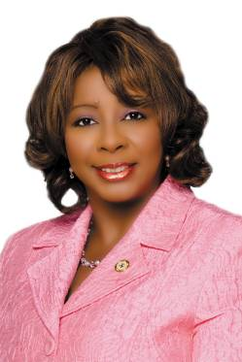

Dear Neighbor,

As we start a new year, our State has found its financial footing through a painful, yet necessary revenue enhancement measure. Despite cuts and reforms, our deficit continued to grow. Through this measure, the legislature was able stabilize Illinois’ fiscal condition and maintain vital services.

Each January marks the celebration of National Blood Donor Month as an opportunity to thank those who donate this precious life-saving resource. Do not forget to thank those you know who have donated and take time to find out how you can help.

Also, I have recently made several changes in how legislative and district information is shared with my community through technology. With a new Web site and electronic newsletter, I hope to better communicate with my constituents.

Sincerely,
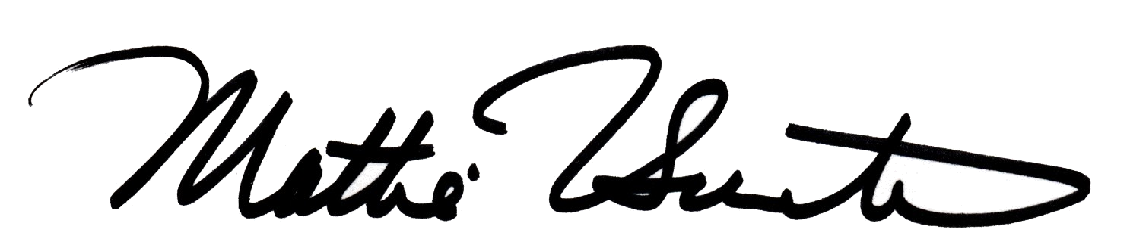
Mattie Hunter
Illinois State Senator
3rd Legislative District

National Blood Donor Month

According to the American Red Cross, every two seconds someone in America needs a blood transfusion. That means over 38,000 individuals need to utilize donated blood on any given day, yet only three out of every 100 people give blood. And since blood only has a shelf life of 42 days, even those who donate regularly cannot keep supply levels stable, even if they donate the maximum limit of six times a year, or every 56 days.

And at this time of year, supplies are at their lowest levels due to inclement weather and seasonal illnesses that prohibit donors from contributing. To help bring more awareness to this cause, each January since 1970 has been designated National Blood Donor Month in recognition of those who have donated. The awareness program is also designed to educate new donors on the simplicity of donating blood.

Those eligible to give blood must be 17 years of age or older and weigh at least 110 pounds. The process is easy and only takes an hour of your time. There are several restrictions for those who should not donate blood and the information can be found on the American Red Cross Web site.

A pint of blood can save up to three lives, giving a donor the opportunity to save up to 18 lives a year. Saving a life is a precious gift, so please do your part today by visiting www.redcrossblood.org to find a local Red Cross near you to donate. Even if you cannot donate, you can still help by planning a blood drive in your community. Also, do not forget to thank a donor this month.

As the American Red Cross says, “The need is constant. The gratification instant. Give Blood.”

3rd District News

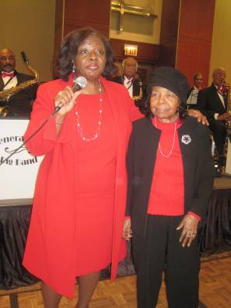
Chasing Away the Blues in Red Annual Senior Luncheon

More than 300 seniors attended a Pre-Holiday Luncheon sponsored by John Corrigan, 42nd Ward Committeeman, and myself, filled with entertainment starring the Generations Big Band at the Hyatt Regency Hotel. It's the 3rd annual luncheon with the first held in honor of the President-Elect Barack Obama. Many seniors could not afford to attend the Inauguration in Washington, D.C the event was made available for 800 seniors to celebrate. They arrived dressed to the nines as a snow storm arrived in Chicago. The following years were themed luncheons called "Chasing Away the Blues in Red" with attendees dressed in Red for the Holiday.

Enjoying Chasing Away the Blues in Red Luncheon with 101-year old Isabel Taylor.

Ham and Turkey Give-Away
Along with Secretary of State Jessie White, Dr. George Smith and Chicago Area Project, Mr. Tim Rand of Midwest Packaging and many other businesses throughout the Chicagoland we teamed up to deliver over 10,000 hams and turkeys to local senior citizen homes and other needy residents. This is my eighth year of participating in this annual event of giving and it has been well received throughout our communities.

Toy Give-Away with Jennifer Hudson



I am somewhere in the sea of children and families while participating in recording artist/ actress Jennifer Hudson’s annual toy drive. Over 5,000 toys were given away to youth in our district and other districts in Chicago.

Healy School 4th Grade class places 3rd in Econ Capitol Challenge Game
Last Fall, I sponsored a fourth-grade math team from Robert Healy Elementary (teacher, Kathleen Bandauskas), that held on to end the competition in third place, edging out the fourth place team from Chicago High School for Agricultural Sciences, by less than $250. Google and Apple turned out to be valuable purchases for the third place team, and combined, they provided an increase of just under $15,000 in equity. Out of the 36 participating schools, Healy had the youngest team as most of the participants were high school students.

Healy was recognized by Econ IL at an in-school assembly on January 18. While overall the S&P 500 grew by just over 100 points since the onset of the competition, participants experienced firsthand how quickly the market can rise and fall. I surprised these little stock market geniuses with an additional certificate from my office and told them I might need their help with my own investments in the future. See more about this outstanding program at http://www.econed-il.org/icee/smg_iccf10_healy_photos.shtml. Healy rocked!!


The Healy School 4th Grade Econ Capitol Challenge Game 3rd Place Winners

New legislative Web site, Twitter and electronic newsletter

In December, my office launched a legislative web site to better inform constituents of the 3rd Legislative District of news, legislative information from Springfield and upcoming district events.

At www.senatorhunter.com, constituents can track my legislation, explore the 3rd District and search useful health awareness and educational materials. More importantly, constituents can utilize a direct news source reporting on significant matters facing the State of Illinois. With many issues discussed in the General Assembly, this Web site will add a level of transparency to state government, giving the public an opportunity to make their voices heard on the issues most important to them and their families.

I will also be utilizing Twitter to give immediate announcements of events, legislative updates and important news. Please follow me at @senmattie3!

In addition, beginning in February, my office will be sending my electronic newsletter in a new format. Please keep an eye out for an E-mail alert to sign up to continue receiving my monthly newsletter or simply sign up on my Web site today.

ISAC Scholars

Congratulations to the following 3rd District students who were named Illinois State Scholars by the Illinois Student Assistance Commission. These young people all had high test scores and are college-bound.

Samuel Austin  Janelli Barrow  Rachel Bowlus  Shelby Brody  Harlan Cao  Andrew Chan  Kessidy Chan  Sean Chang  Jing Chen  Louis Chen  Pikyu Cheng  Lauren Cheung  Carrie Chui  Theodora Cunningham  Alexandria Diloreto  Emelia Fredlick  Jaqueline Hernandez  Ryan Huang | Jordan Hui  Vicente Iniguez  Baoyi Jiang  Vincent Kenny  Hunter Kern  Lauren Lee  Vivian Li  Leslie Liang  Cindy Mei  Madeleine Mermall  Alexandra Moussa-Tooks  Melissa Owens  Robert Parrillo  Heather Pedziwiatr  Gabriel Perez  Margaret Porucznik  Stephen Prince  Jessica Ramirez | Jiahui Shi  Chumin Situ  Hannah Spooner  Kyle Szeto  Jessica Tang  Tina Umanskiy  Angela Wong  Jacky Wu  Kate Wu  Rita Wu  Nicole Yoon  Megan York  Erin Young  Ashley Youssef  Ivy Zhao  Tommy Zheng

Around Springfield



I celebrated with newly elected/re-elected State Officials, along with Janis McReynolds (District Administrator) and Lucretia Newman (Legislative Assistant) at the Inaugural Ball.

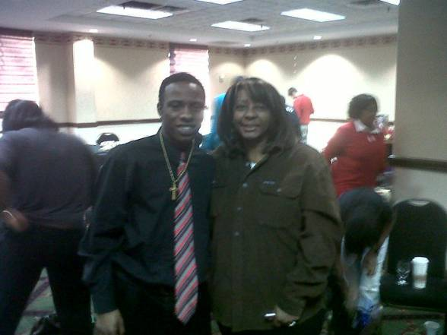

On January 8, I enjoyed meeting and having fun with the counselors and youth who took part in a Statewide Youth Advisory Board Conference in Springfield and advised on how to draft and solicit sponsorship for proposed legislation.
The Statewide Youth Advisory Board (SYAB) is an innovative program within the Department of Community Development and Organizing (DCDO). This program is exclusively provided for Youth in Care of the State of Illinois. The SYAB is a program that provides services and opportunities for youth and young adults between the ages of 14-21. The program is a safe place to voice individual as well as community issues and concerns relating to programming, services, and policies provided by the Illinois Department of Children and Family Services

Legislative News

Service providers applaud necessary revenue enhancements and push for restructuring bonds
Earlier this month, Senator Delgado, Senator Trotter and I held a press conference to discuss the recent passage of the State Revenue and Budget Stabilization Package. We were joined by health and human service providers and non-profits from across the state.

Senate Bill 2505 increases personal income tax by 2 percentage points and the corporate income tax by 2.2 percentage points. The measure also forces the General Assembly, by law, to cap state spending at two percent. As a promise to the Illinois taxpayers that government will live within its means, the tax increases will be revoked if the legislature spends more than the cap. The bill was signed by Governor Quinn the day following its passage.

Presenters also called for the passage of Senate Bill 3 that would create General Obligation Restructuring Bonds and allow the State to pay off its current obligations to health and human service providers and educational facilities as well as paying corporate income tax refunds. Illinois approximately has $8.2 billion in unpaid bills for Fiscal Year 2011, including $900 million in corporate refunds and $800 million in state group insurance backlog.

Illinois is currently facing $9 billion in bills in Fiscal Year 2010 and without quick, responsible action, that figure was expected to climb to nearly $15 billion by Fiscal Year 2011. To give some perspective to the issue, Illinois schools are waiting for over $1 billion in payments for operational and personnel costs. Chicago Public Schools are waiting for close to $335 million. Human Services alone is currently facing $28 million in cuts for developmentally disabled grant programs and $45 million in cuts to community based mental health programs due to lack of desperately needed state funds. Police and fire departments are also experiencing similar operational and personnel funding concerns.

Much conversation around the state focused on implementing cuts and reforms before revenue enhancements should be considered. For the past two years, the General Assembly worked vehemently cut waste, fraud and rein in spending. To cut costs we passed legislation adjusting pension benefits for State employees – including legislators – saving our State over $72 billion over the next 35 years. We addressed fraud and waste in the Medicaid system by tightening eligibility requirements and strengthening penalties for those who take advantage of the system. To prove that we all must share in the sacrifice, the General Assembly voted to cut our own pay by 5% and froze our own cost of living adjustments and those of other State officials. Over the past two years alone, the General Assembly has cut appropriations by $4.4 billion, nearly 14 percent.

This measure will allow the State the opportunity to pay our bills going forward. Through this increase we will be able to raise almost over $7 billion to pay our pension services, making debt service payment on bonds, payments owned to vendors and other state obligations made in this fiscal year.

Death penalty abolished with recent legislation

In 2000, Governor George Ryan placed a moratorium on death penalties in the state after it was found that 12 innocent people were executed in the process. The investigation also found that there were 13 inmates also on death row that were found innocent and exonerated. I sponsored Senate Bill 3539 abolishing the death penalty and prohibiting the death penalty sentence in any case.

Statistics show that the Illinois death penalty sentencing process is erroneous. Too many innocent people have been sentenced to death. Even one innocent individual was too many to have been executed under this system. For those individuals whom were found innocent before their execution, the time they spent on death row knowing their fate; they will never get that time back.

Opponents of the legislation claim that some heinous crimes deserve the ultimate punishment of the death penalty. But my belief is that too many innocent lives have been lost due to wrongful executions and the State should discontinue the program.

Innocent lives have been lost because of the death penalty. Those individuals and their families lost the opportunity to enjoy a loving, peaceful existence together because of a broken system. I also believe that using the death penalty as a tool to coerce a confession out of a guilty individual is flawed and does not bring closure to the families of victims.

